An Explainable QR Code Analysis for Detecting Phishing and Malicious URLs Using Machine Learning
A thesis report submitted to the department of Computer Science and Engineering of the World University of Bangladesh in partial fulfillment of the requirement for award of the degree of Bachelor of Science in Computer Science & Engineering

Submitted by:
Md Shahidul Islam  Id: WUB 03/23/63/3735 | Md Riad Khan  Id: WUB 03/23/63/3738 | Md Zonaet Hossain Munna  Id: WUB 03/23/63/3746

Supervised by:
Mst. Nishita Aktar, Lecturer
Dept. of Computer Science and Engineering

World University of Bangladesh
Department of Computer Science and Engineering

June, 2026
LETTER OF TRANSMITTAL

June 27, 2026

To
Mst. Nishita Aktar
Lecturer, Department of Computer Science & Engineering
World University of Bangladesh (WUB)
Avenue 6, Lake Drive Road, Sector: 17/H
Uttara, Dhaka-1230, Bangladesh

Subject: Submission of Thesis Report.

Dear Madam,
We are pleased to submit the thesis entitled "An Explainable QR Code Analysis for Detecting Phishing and Malicious URLs Using Machine Learning". It was a great pleasure to work on such an important topic. The report is prepared according to the requirements and guidelines of the Department of Computer Science and Engineering, World University of Bangladesh (WUB).

We believe that the report will help you in evaluating our thesis work. It would be a great pleasure for us to explain any part or whole of the report whenever necessary.

Sincerely yours:  Md Shahidul Islam  WUB 03/23/63/3735 | Sincerely yours:  Md Riad Khan  WUB 03/23/63/3738 | Sincerely yours:  Md Zonaet Hossain Munna  WUB 03/23/63/3746


World University of Bangladesh
DECLARATION

We hereby solemnly declare that the thesis work entitled "An Explainable QR Code Analysis for Detecting Phishing and Malicious URLs Using Machine Learning", has been supervised by Mst. Nishita Aktar, Lecturer, Department of Computer Science & Engineering, World University of Bangladesh. We ensure that the thesis report has not been submitted either in whole or part for any degree or Diploma in any university previously.

We hereby warrant that the work we have presented does not breach any existing copyright rule.

We further undertake to indemnify the university against any loss or damage arising from breach of the forgoing obligation.

Sincerely yours:  Md Shahidul Islam  WUB 03/23/63/3735 | Sincerely yours:  Md Riad Khan  WUB 03/23/63/3738 | Sincerely yours:  Md Zonaet Hossain Munna  WUB 03/23/63/3746



Department of Computer Science and Engineering
World University of Bangladesh
CERTIFICATE

I hereby certify that the thesis Report on "An Explainable QR Code Analysis for Detecting Phishing and Malicious URLs Using Machine Learning", is a genuine record of thesis work done by Md Shahidul Islam, Md Riad Khan & Md Zonaet Hossain Munna for partial fulfillment of the requirements for award of the degree of the Bachelor of Science in Computer Science and Engineering from World University of Bangladesh.

The thesis report has been carried out under my guidance and is a record of the work carried out successfully by the students.

Supervisor:

………………………
Mst. Nishita Aktar
Lecturer, Department of Computer Science and Engineering
World University of Bangladesh (WUB)

ACKNOWLEDGEMENTS

We begin by expressing our gratitude to Almighty Allah for granting us the wisdom, endurance, and resolve to complete this research.
We owe our deepest gratitude to our thesis supervisor, Mst. Nishita Aktar, Lecturer, Department of Computer Science and Engineering, World University of Bangladesh, for her meticulous guidance, scholarly advice, and continuous encouragement throughout this work. Her constructive feedback and thoughtful direction were pivotal in refining both the technical depth and the overall quality of this thesis.
We sincerely thank the faculty members of the Department of Computer Science and Engineering, World University of Bangladesh (WUB), for their academic mentorship and for equipping us with the foundational knowledge that made this research possible.
We gratefully acknowledge the contribution of each group member — Md Shahidul Islam, Md Riad Khan, and Md Zonaet Hossain Munna — whose collective effort, intellectual engagement, and shared dedication were essential in bringing this project to completion. The collaborative spirit of this team was one of the greatest strengths of this research.
Finally, we reserve our most heartfelt appreciation for our families, who provided unconditional support, patience, and encouragement at every stage of this journey. Without their belief in us, this work would not have been possible.

Signature of Student  …………………..  Md Shahidul Islam  WUB 03/23/63/3735 | Signature of Student  ………………  Md Riad Khan  WUB 03/23/63/3738 | Signature of Student  ………………….  Md Zonaet Hossain Munna  WUB 03/23/63/3746

ABSTRACT

QR codes have become integral to digital payments, authentication, and information sharing, yet they pose a significant cybersecurity risk: users cannot inspect an embedded URL before scanning, allowing attackers to conceal phishing and malicious links inside QR codes — a threat widely known as "quishing" — while standard QR scanners provide no security validation prior to redirecting users.
A thorough review of existing literature across URL-based machine learning, deep learning-based phishing detection, explainable AI, and QR code security reveals three critical gaps: the absence of QR-specific detection systems, the lack of explainability in QR-focused work, and the limitation of prior research to binary classification, all of which this study directly addresses.
To fill these gaps, a large multi-source dataset of 402,684 URLs was constructed from a labelled benchmark dataset, live OpenPhish and URLhaus threat feeds, global domain lists, and university domains, further augmented with synthetic brand-impersonation and hard-negative examples to improve robustness against typosquatting and combosquatting attacks.
A dual-input Transformer-based neural network was designed, combining a character-level encoder with a brand-similarity feature tower, and deployed within a modular pipeline system that decodes the QR code, normalizes the embedded URL, classifies it into one of four risk categories — Benign, Phishing, Malware, or Defacement — and generates a human-readable explanation for each prediction.
The trained model achieved an overall test accuracy of 91.2% on a held-out test set of 41,167 URLs, and 93% accuracy in the practical safe-versus-threat binary view, with an ROC-AUC of approximately 0.97, while a dedicated generalization test confirmed the model's ability to detect brand impersonation attacks built from brand names deliberately withheld during training.
Despite residual limitations such as occasional false positives on genuine brand root domains and the use of rule-based rather than formal feature-attribution explanations, the proposed framework establishes a practical and reproducible foundation for QR code phishing detection, with future work directed toward adding a SHAP/LIME-style explanation layer, expanding brand coverage, incorporating live destination-page analysis, and deploying the system as a real-time mobile or browser-based security tool.

Table of Contents Page No
Letter of Transmittal ii
Declaration iii
Certificate iv
Acknowledgement v
Abstract vi
Table of Contents vii
List of Tables ix
List of Figures x
Abbreviations xi
Chapter 1: Introduction 1
- Introduction 1
- Objectives 1
- Justification of Study 2
- Scope of Study 2
Chapter 2: Literature Review 2
- 2.1 Introduction 2
- 2.2 URL-Based Machine Learning Approaches 3
- 2.3 Deep Learning-Based Phishing Detection 3
- 2.4 Explainable Artificial Intelligence in Phishing Detection 4
- 2.5 QR Code Phishing and Security 4
- 2.6 Research Gap 4
Chapter 3: Methodology 10
- 3.1 Justification of Methodology 11
- 3.2 Description of Methodology 12
3.2.1 Requirement Analysis 12
3.2.2 Dataset Collection 12
3.2.3 Data Preprocessing 13
3.2.4 Model Training 14
3.2.5 Evaluation 16
3.2.6 Program Testing 16
Chapter 4: Requirement Analysis, Design, and Development 18
- 4.1 Introduction 18
- 4.2 System Requirement Analysis 18
- 4.3 Functional Requirements 18
4.3.1 QR Code Input and Decoding 18
4.3.2 URL Normalization and Feature Extraction 18
4.3.3 Classification 18
4.3.4 Result Generation 18
4.3.5 Explanation Generation 18
4.3.6 Use-Case Summary 19
- 4.4 Non-Functional Requirements 19
4.4.1 Performance 19
4.4.2 Reliability 19
4.4.3 Scalability 20
4.4.4 Usability 20
- 4.5 System Architecture Design 20
- 4.6 Workflow Design 21
- 4.7 Data Flow Diagram 22
- 4.8 Database Design 23
- 4.9 Development Environment 23
Chapter 5: Project Description 25
- 5.1 Introduction 25
- 5.2 Dataset Implementation 25
- 5.3 Preprocessing and Feature Engineering Implementation 25
- 5.4 Model Implementation 26
- 5.5 Model Training 26
- 5.6 Experimental Results 27
- 5.7 Confusion Matrix Analysis 28
- 5.8 Classification Report and Security-View Metrics 29
- 5.9 Training Curves and Prediction Confidence 30
- 5.10 Generalization Test on Real-World and Held-Out Brands 31
- 5.11 Ablation Study: Contribution of the Brand-Similarity Features 33
- 5.12 Application Interface and End-to-End Demonstration 33
- 5.13 Discussion 37
Chapter 6: Conclusion 38
- 6.1 Introduction 38
- 6.2 Research Summary 38
- 6.3 Research Contribution 39
- 6.4 Limitations 40
- 6.5 Future Work 40
- 6.6 Final Conclusion 41

List of tables

Table 2.1: Comparative Analysis of Literature 8
Table 3.1 summarizes the per-class composition of the final combined dataset before balancing. 13
Table 3.1: Dataset composition by class (before balancing) 13
Table 3.2: Per-class samples used for training/validation/testing 14
Table 3.3: Dataset splitting 14
Table 3.4: Model training configuration 16
Table 4.1: scan_records database schema 23
Table 4.2: Development environment technologies 24
Table 5.1: Training progression (selected epochs) 27
Table 5.2: Per-class classification report on the test set 27

List of Figures
Figure 3.1: Research Workflow Pipeline 11
Figure 3.2: Dual-Input Model Architecture 15
Figure 4.1: Use Case Diagram 19
Figure 4.2: System Architecture Design 21
Figure 4.3: Sequence Diagram 22
Figure 4.4: Data Flow Diagram 23
Figure 5.1: Training/validation accuracy & loss curves 26
Figure 5.2: 4×4 confusion matrix heatmap 28
Figure 5.3: Per-class F1 bar chart 29
Figure 5.4: ROC curve (safe vs threat) 30
Figure 5.5: Confidence histogram (correct vs wrong) 31
Figure 5.6: Screenshot of legit/phish/held-out test results 33
Figure 5.7 shows the web application classifying a legitimate URL, where the result card reports a Safe verdict with the decoded destination and supporting indicators. Figure 5.8 shows the same interface classifying a phishing URL, where the verdict changes to a high-confidence Dangerous result with the threat type identified. 34
Figure 5.7: Web application — Safe (benign) result 34
Figure 5.8: Web application — Phishing (Dangerous) result 35
Figure 5.9: Mobile application — Safe (benign) result 36
Figure 5.10: Mobile application — Phishing (Dangerous) result 37

Abbreviations
Short form | Full Form
AI | Artificial Intelligence
API | Application Programming Interface
AUC | Area Under the Curve
CNN | Convolutional Neural Networks
Conv1D | Convolutional 1D Layer
CSV | Comma-Separated Values
DL | Deep Learning
DT | Decision Tree
EDA | Exploratory Data Analysis
F1 | F1 Score (Harmonic Mean of Precision and Recall)
GBM | Gradient Boosting Machine
HTTP/HTTPS | HyperText Transfer Protocol / Secure
IEEE | Institute of Electrical and Electronics Engineers
LIME | Local Interpretable Model-agnostic Explanations
LLM | Large Language Model
LR | Logistic Regression
ML | Machine Learning
NB | Naïve Bayes
QR | Quick Response
RF | Random Forest
ReLU | Rectified Linear Unit
ROC | Receiver Operating Characteristic
SHAP | SHapley Additive exPlanations
SVM | Support Vector Machine
URL | Uniform Resource Locator
WUB | World University of Bangladesh
XAI | Explainable Artificial Intelligence
XGBoost | Extreme Gradient Boosting

Chapter 1: Introduction

Introduction
The rapid expansion of digital infrastructure has brought QR codes into nearly every aspect of daily life — from restaurant menus and transit ticketing to banking applications and government services. Their convenience is undeniable: a single scan bridges the physical and digital world in an instant. Yet this seamlessness comes at a cost. Unlike a typed URL that a user can read and evaluate, a QR code reveals nothing about its destination before the redirect occurs.
Attackers have learned to exploit this blind spot. By embedding phishing or malicious URLs inside an otherwise ordinary-looking QR code, they can redirect unsuspecting users to fraudulent websites, credential-harvesting pages, or malware distribution servers — all without triggering the suspicion that a suspicious-looking link might otherwise raise. This attack vector, commonly termed "quishing," is particularly dangerous because it sidesteps the visual scrutiny that users have been trained to apply to traditional phishing attempts.
Despite the growing scale of this threat, mainstream QR scanning tools continue to decode and open embedded links without any form of security assessment. Machine learning approaches have shown considerable promise in detecting phishing URLs within web and email contexts, but these systems were not designed with QR-based delivery in mind and offer little transparency into how their decisions are reached.
This research proposes a solution: an explainable machine learning framework that decodes the URL from a scanned QR code, classifies it as Benign, Phishing, Malware, or Defacement using a dual-input Transformer-based model, and provides a clear, human-readable explanation for every prediction — turning an opaque security verdict into an informative, trustworthy decision aid.

Objectives
- To propose a novel machine learning-based model for explainable QR code analysis to detect phishing and malicious URLs.
- To evaluate the accuracy level of the proposed system in comparison with existing models.

Justification of Study
QR code usage has grown faster than the security awareness surrounding it. Users across all demographics scan QR codes daily with little to no understanding of the risks involved, and no existing scanning tool alerts them before a potentially harmful redirect takes place. While phishing detection as a field is well-established, no widely available solution addresses the specific context of QR-delivered threats, nor does any existing tool explain its reasoning to the user in an accessible way. This gap — between how widely QR codes are trusted and how poorly that trust is protected — is precisely what motivates this study.

Scope of Study
This study proposes and evaluates a machine learning framework capable of classifying URLs decoded from QR codes into four categories: Benign, Phishing, Malware, and Defacement. The research contributes a multi-source dataset of 402,684 URLs, a dual-input Transformer-based model combining character-level encoding with brand-similarity features, and an explainability layer that provides human-readable reasoning for each prediction. The system is validated on a held-out test set as well as on real-world URLs and brand impersonation attacks unseen during training. Detection is limited to URL-text analysis and does not include destination-page inspection or non-URL QR content — areas identified as directions for future work. A prototype web and mobile application that calls the trained model end-to-end is demonstrated in Section 5.12; hardening it into a production-grade deployment with on-device inference remains a direction for future work.

Chapter 2: Literature Review

2.1 Introduction
Phishing detection has been an active research area in cybersecurity for over a decade. Early defenses relied mainly on blacklist- and signature-based filtering, but these approaches could not keep pace with the constant creation of new and previously unseen malicious links. To overcome this limitation, researchers shifted toward machine learning (ML) and deep learning (DL) techniques that can learn discriminative patterns directly from data. More recently, two further concerns have shaped the field: the rise of QR-code-based phishing ("quishing"), and the demand for explainable models that can justify their predictions rather than acting as opaque black boxes. This chapter reviews the relevant literature across four themes — URL-based machine learning approaches, deep-learning-based detection, explainable artificial intelligence in phishing detection, and QR-code-specific security — and identifies the research gap that this study addresses.

2.2 URL-Based Machine Learning Approaches
A significant volume of research conceptualizes phishing detection as a URL classification task, predominantly relying on handcrafted features. Sahoo, Liu and Hoi (2017) provide a widely cited survey of malicious URL detection using machine learning, organizing the field around feature categories such as lexical, host-based, and content-based features and the learning algorithms applied to them. Building on lexical analysis, Jaswanthi et al. (2024) carried out a comparative study of machine learning algorithms for malicious URL detection, extracting features such as domain reputation, URL length, and the presence of suspicious characters, and evaluating performance using precision, recall, F1-score, and accuracy. Hamadouche, Boudraa and Gasmi (2024) extended this idea by combining lexical, host, and content-based features on a balanced dataset, applying feature-selection techniques before comparing four models (SVM, Decision Tree, Random Forest, and XGBoost). Collectively, these studies confirm that structural and lexical properties of a URL carry strong signals for phishing detection, although they depend heavily on manual feature engineering and are not designed for QR-based threats.

2.3 Deep Learning-Based Phishing Detection
To reduce dependence on hand-crafted features, several researchers adopted deep learning models that learn representations automatically. Aljofey et al. (2020) proposed a character-level convolutional neural network (CNN) that classifies phishing URLs using only the URL string, without retrieving website content or relying on third-party services, capturing sequential patterns directly from the characters. Yang et al. (2021) combined deep learning with ensemble learning, using character embeddings and a multi-level CNN for feature extraction followed by multiple Random Forest classifiers in a winner-take-all scheme, reporting an accuracy of 99.35%. Aldakheel et al. (2023) applied a one-dimensional CNN with character embeddings to URL data drawn from PhishTank, while Qazi, Faheem and Ahmad (2024) presented a further deep-learning approach aimed at preventing cyber-attacks through phishing-URL detection. These works demonstrate that deep models can achieve very high accuracy, but they generally operate as black boxes and focus on textual URLs rather than QR-encoded links. MDPI

2.4 Explainable Artificial Intelligence in Phishing Detection
A growing line of research argues that detection accuracy alone is insufficient, and that models must also explain their decisions to earn user trust. Shafin (2024) introduced an explainable feature-selection framework for web phishing detection, using SHAP for global feature attribution and aggregated LIME for local explanations to identify the most influential features. Mohi et al. (2025) proposed an explainable approach based on boosting models (Random Forest, XGBoost, and gradient boosting) paired with SHAP and LIME, with XGBoost reaching an accuracy of 97.78% while remaining interpretable at both global and local levels. Lim et al. (2025) presented EXPLICATE, which couples a machine-learning classifier with a dual LIME-and-SHAP explanation layer and a large language model that translates technical explanations into readable natural language, attaining 98.4% accuracy with improved transparency. These studies establish that explainability and high accuracy can coexist, but they target emails and web URLs rather than QR codes. Wiley Online LibraryarXiv

2.5 QR Code Phishing and Security
Research specific to QR codes has historically emphasized human behavior and the attack surface. Vidas et al. (2013) conducted the first empirical study of QR-code phishing ("QRishing"), running field experiments that showed users frequently scan QR codes out of curiosity without verifying their destination, exposing them to malicious redirects. Krombholz et al. (2021) surveyed QR-code security, providing a taxonomy of attacks and the usability challenges that make QR codes a persistent threat vector. More recently, Trad and Chehab (2025) proposed detecting quishing by analyzing the QR code's structure and pixel patterns directly, without first decoding the embedded content; training several models (Logistic Regression, Decision Tree, Random Forest, Naïve Bayes, LightGBM, and XGBoost) on QR images generated from benign and phishing URLs, their best model reached an AUC of 0.9106. This work is the closest to the present study, but it performs only binary classification and provides limited explanation of its decisions. arXiv

2.6 Research Gap
The reviewed literature reveals three clear gaps.
- The majority of high-performing detection systems are designed for general web or email URLs rather than QR-code-specific attacks.
- While explainable AI has been applied successfully to web and email phishing, it has not been meaningfully integrated into QR-code detection.
- Existing QR-focused work is largely limited to binary (benign vs. malicious) classification and offers little transparency for the end user.
These gaps motivate a QR-specific, explainable system that goes beyond binary output.
Study | Method | Focus Area | Core Concept | Limitation
Malicious URL Detection using Machine Learning: A Survey, (Sahoo et al., 2017) | ML survey | Malicious URL detection | Organizes lexical, host, and content features and ML techniques for URL detection | Survey only; no QR focus
Malicious URL Detection: Comparative Study of Machine Learning Algorithms. (Jaswanthi et al., 2024) | Comparative ML (lexical) | Malicious URL detection | Domain reputation, URL length, suspicious characters drive detection | No explainability; not QR-specific
Combining Lexical, Host, and Content-based features for Phishing Websites detection using Machine Learning Models. (Hamadouche et al., 2024) | ML (SVM, DT, RF, XGBoost) | Phishing website detection | Combining lexical + host + content features improves accuracy | Manual feature engineering; not QR-based
An Effective Phishing Detection Model Based on Character Level Convolutional Neural Network from URL. (Aljofey et al., 2020) | Character-level CNN | Phishing URL detection | Learns URL patterns automatically; no content or third-party services needed | Black-box; not designed for QR codes
Phishing Website Detection Based on Deep Convolutional Neural Network and Random Forest Ensemble Learning. (Yang et al., 2021) | CNN + Random Forest ensemble | Phishing website detection | Char embedding + multi-level CNN + RF (winner-take-all); ~99.35% accuracy | Low explainability; not QR-specific
A Deep Learning-Based Innovative Technique for Phishing Detection in Modern Security with Uniform Resource Locators. (Aldakheel et al., 2023) | 1D CNN + char embedding | Phishing URL detection | Character-level deep model on PhishTank URLs | URL-only; no explanation or QR support
Detecting Phishing URLs Based on a Deep Learning Approach to Prevent Cyber-Attacks. (Qazi et al., 2024) | Deep learning (CNN) | Phishing URL detection | Deep-learning approach to prevent phishing-based cyber-attacks | URL-only; not explainable; not QR
An Explainable Feature Selection Framework for Web Phishing Detection with Machine Learning. (Shafin, 2024) | XAI feature selection (SHAP + LIME) | Web phishing detection | Explainable feature selection improves model transparency | Web features only; not QR-based
Explainable Machine Learning for Phishing Site Detection: A High-Efficiency Approach Using Boosting Models and SHAP. (Mohi et al., 2025) | Boosting (RF, XGBoost, GBM) + SHAP/LIME | Phishing site detection | Interpretable boosting; XGBoost reaches 97.78% accuracy | Website features; not QR-based
EXPLICATE: Enhancing Phishing Detection through Explainable AI and LLM-Powered Interpretability. (Lim et al., 2025) | ML + LIME + SHAP + LLM | Phishing detection (explainable) | Dual explanation plus LLM natural-language insight; 98.4% accuracy | Email/URL focus; not QR
QRishing: The Susceptibility of Smartphone Users to QR Code Phishing Attacks. (Vidas et al., 2013) | User-behavior experiments | QR phishing susceptibility | Users scan QR codes blindly out of curiosity, increasing risk | No detection system
QR Code Security: A Survey of Attacks and Challenges for Usable Security. (Krombholz et al., 2014) | Survey | QR code security | Taxonomy of QR attacks and usability challenges | Conceptual; no detection implementation
Detecting Quishing Attacks with Machine Learning Techniques Through QR Code Analysis. (Trad & Chehab, 2025) | ML on QR pixels (LR, DT, RF, NB, LightGBM, XGBoost) | Quishing detection | Analyzes QR structure/pixels directly without decoding; XGBoost AUC 0.9106 | Binary only; limited explainability
Our Proposed Work | CNN + ML + Explainable AI | QR phishing detection | Classifies Safe / Risky / Dangerous with explanations for user trust | Needs real-world deployment
Table 2.1: Comparative Analysis of Literature
To address these gaps, this research proposes an explainable machine-learning system for QR-code phishing detection. The system extracts the URL embedded in a QR code and analyzes it using a dual-input model that combines a character-level Transformer encoder with engineered brand-similarity features. Unlike prior QR-focused work, it classifies the decoded URL into one of four categories — benign, phishing, malware, or defacement — which are then mapped to the user-facing risk levels of Safe, Risky, or Dangerous, and it provides clear, human-readable explanations for each prediction, thereby improving both detection capability and user trust.

Chapter 3: Methodology
The proposed methodology consists of six major phases. First, a requirement analysis was conducted to define the system objectives, scope, and expected outcomes. Next, a comprehensive dataset was collected by gathering URLs and related information from multiple sources to ensure diversity and reliability. The collected data then underwent preprocessing, including normalization, tokenization, and augmentation, to improve data quality and prepare it for model training. After preprocessing, a dual-input Transformer-based model was trained to learn meaningful patterns and relationships from the input data. The trained model was subsequently evaluated using standard performance metrics such as Accuracy, F1-score, and ROC-AUC to assess its effectiveness. Finally, extensive program testing was performed using real-world samples and previously unseen brand data to validate the robustness, reliability, and practical applicability of the proposed system. Although described as a sequence, in practice these phases were applied iteratively, in the spirit of agile development, with evaluation outcomes feeding back into preprocessing and model training until the model generalized reliably to previously unseen brand-impersonation cases.

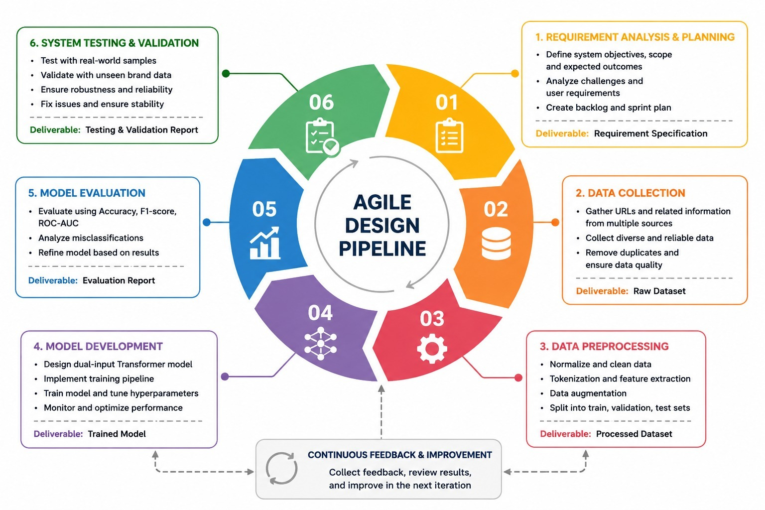
Figure 3.1: Agile Research Workflow Pipeline

3.1 Justification of Methodology
The methodology of this research was designed around a single core insight: a QR code is only a lossless visual encoding of text, meaning a safe and a malicious QR code are visually indistinguishable as patterns of black-and-white modules. The actual risk lies entirely in the destination URL the code encodes. For this reason, treating the problem as a URL-text classification task — rather than a QR image classification task — is both more direct and more data-efficient, and this decision shaped every subsequent methodological choice.
A multi-source dataset was constructed rather than relying on a single benchmark because static datasets age quickly and no single source adequately represents the full diversity of real-world threats and legitimate domains. Live threat feeds were incorporated alongside global domain lists and university domains to ensure the model was exposed to both current attack patterns and a realistic range of benign URLs. Brand-attack augmentation with typosquatting, combosquatting, and subdomain-abuse examples was necessary because a character-level model alone cannot reliably separate a genuine brand domain from a deliberate look-alike differing by only one or two characters. Hard-negative examples — genuine brand domains with sensitive-looking paths — were included to prevent the model from incorrectly associating words like "login" with phishing regardless of which domain they appeared on.
A dual-input architecture fusing a character-level Transformer encoder with engineered brand-similarity features was chosen because the two towers address fundamentally different aspects of the detection problem: the character tower captures general URL-level threat signals, while the brand-similarity tower specifically targets impersonation attacks. A four-class formulation was preferred over binary classification to provide a more fine-grained risk signal and to enable per-class evaluation that reveals exactly where the model performs well and where it struggles. Finally, a dedicated generalization test on brand names deliberately withheld from training was included because standard train-test splits alone cannot confirm whether a model has learned a transferable pattern or merely memorized specific examples seen during training.

3.2 Description of Methodology
The research methodology followed six core phases to develop and validate the proposed QR code phishing detection system. Figure 3.1 illustrates the overall research workflow. As the feedback loop in Figure 3.1 indicates, the phases were iterative rather than strictly linear: insights from the evaluation phase were fed back into preprocessing and training, and that cycle was repeated until performance stabilized. Following an agile structure, each phase yields a concrete deliverable — a requirement specification, the raw dataset, the processed dataset, the trained model, an evaluation report, and a testing-and-validation report, respectively — that feeds into the next phase.

3.2.1 Requirement Analysis
The methodology began with a formal requirement analysis to define the scope and objectives of the system. This phase identified that the core functional requirements of the system were: the ability to accept a QR code as input and decode its embedded URL, classify the decoded URL into one of four risk categories, and provide a human-readable explanation for each prediction. Non-functional requirements including prediction speed, classification consistency, and scalability for future retraining were also established at this stage. The threat model was explicitly scoped to URL-text-based analysis, covering phishing, malware, and defacement attacks delivered through QR codes, and excluding non-URL QR content such as contact cards or Wi-Fi credentials. This phase provided the foundational boundaries within which all subsequent decisions were made.

3.2.2 Dataset Collection
Following the requirement analysis, a large multi-source dataset was constructed to provide broad and realistic coverage of both malicious and benign URLs. Four sources were combined: a labelled benchmark dataset containing URLs pre-categorized as benign, phishing, malware, or defacement; live threat feeds from OpenPhish and URLhaus providing recently active phishing and malware-distribution URLs; the Cisco Umbrella top global domain list supplying a diverse pool of legitimate websites; and approximately nine thousand university domains spanning .edu, .edu.bd, and .ac.* suffixes worldwide to represent institutional benign patterns. All four sources were merged, deduplicated, and saved into a single reproducible dataset file, producing a total of 402,684 labelled URLs across four classes.
All four sources were merged, deduplicated, and saved into a single combined CSV file so that the dataset-construction step is reproducible and does not need to be repeated on every run.
Table 3.1 summarizes the per-class composition of the final combined dataset before balancing.

Class | Label | Number of URLs
Benign | 0 | 142,052
Phishing | 1 | 130,880
Malware | 2 | 34,444
Defacement | 3 | 95,308
Total | — | 402,684
Table 3.1: Dataset composition by class (before balancing)

3.2.3 Data Preprocessing
With the dataset in place, each URL underwent a structured preprocessing pipeline before being passed to the model. First, every URL was normalized by converting it to lowercase, removing the HTTP or HTTPS scheme prefix, and stripping any leading "www." subdomain. The normalized string was then tokenized at the character level and padded or truncated to a fixed length of 200 characters. In parallel, four numerical brand-similarity features were computed for each URL — capturing exact brand or subdomain matches, minimum edit distance to known brand domains, near-miss signals, and homoglyph substitution patterns. The dataset was further augmented with synthetically generated brand-attack examples including typosquatting, combosquatting, and subdomain-abuse variants, alongside benign hard-negative examples placing genuine brand domains with sensitive-looking paths into the benign class. Finally, a stratified 70/15/15 split was applied to divide the data into training, validation, and test subsets, with class weights computed to compensate for the smaller malware class. Table 3.2 shows the number of samples used per class after capping.
Class | Samples used
Benign | 80,000
Phishing | 80,000
Malware | 34,444
Defacement | 80,000
Table 3.2: Per-class samples used for training/validation/testing
The combined, balanced dataset was then split into training, validation, and test subsets using a stratified 70/15/15 split, ensuring that every class is proportionally represented in each subset. Table 3.3 shows the resulting split sizes.
Subset | Number of URLs | Percentage
Training set | 192,110 | 70%
Validation set | 41,167 | 15%
Test set | 41,167 | 15%
Table 3.3: Dataset splitting
Because the malware class remained smaller than the other three classes even after capping, class weights were computed (inversely proportional to class frequency) and applied during training, so that the model is penalized more heavily for misclassifying rarer classes instead of being biased toward the majority classes.

3.2.4 Model Training
Using the preprocessed dataset, a dual-input Transformer-based neural network was designed and trained. The model accepted two parallel inputs — the 200-character URL sequence and the four brand-similarity features — and processed them through two separate towers before merging them for final classification. The character tower passed the input sequence through an embedding layer, a Conv1D layer for local pattern detection, a Multi-Head Self-Attention block with four heads, and a position-wise feed-forward sub-layer (Dense 128 then Dense 64) — each of the two sub-layers wrapped with a residual connection and layer normalization — followed by global max pooling and a dense projection. The brand-similarity tower passed the four engineered features through a small dense layer. The outputs of both towers were concatenated and passed through a final softmax classification head producing probabilities for four classes: benign, phishing, malware, and defacement. The model was trained for up to 15 epochs using the Adam optimizer, sparse categorical cross-entropy loss, a batch size of 128, and class weighting. Early stopping with a patience of three epochs and learning rate reduction on plateau were applied throughout training to prevent overfitting. The character-level encoder follows prior character-CNN approaches to URL classification (Aljofey et al., 2020); the self-attention block follows the Transformer architecture (Vaswani et al., 2017); and optimization uses the Adam algorithm (Kingma and Ba, 2015). The complete architecture is illustrated in Figure 3.2.
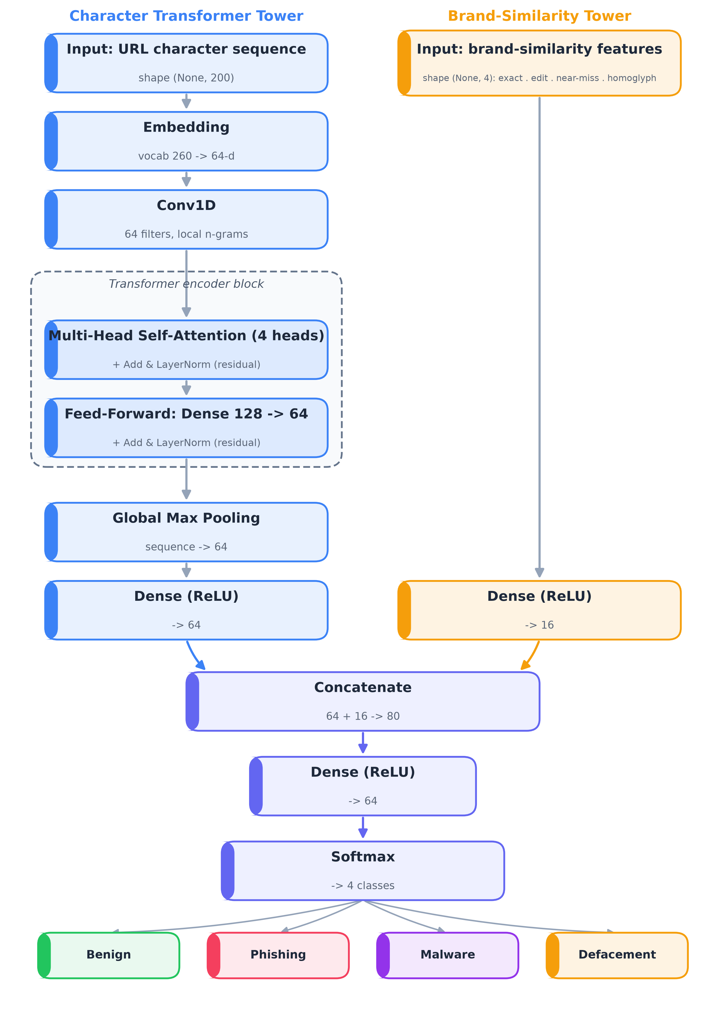
Figure 3.2: Dual-Input Model Architecture
Formally, the character tower maps the input sequence to an embedding matrix E ∈ ℝ^(V×d), applies a 1-D convolution for local context, and then a multi-head self-attention block defined as Attention(Q, K, V) = softmax((Q·Kᵀ)/√dₖ)·V, computed in parallel over h heads. The fused representation z is mapped to a class distribution by a softmax layer, ŷ = softmax(W·z + b). Training minimises the sparse categorical cross-entropy loss L = −(1/N) Σᵢ log p(yᵢ | xᵢ), where N is the number of training samples and p(yᵢ | xᵢ) is the predicted probability of the true class for sample i.
The model was implemented in TensorFlow/Keras and compiled with the configuration shown in Table 3.4.

Parameter | Value
Optimizer | Adam
Loss function | Sparse categorical cross-entropy
Activation functions | ReLU (hidden layers), Softmax (output layer)
Epochs (maximum) | 15
Batch size | 128
Class weighting | Applied (inverse class-frequency)
Random seed | 42 (fixed, for reproducibility)
Table 3.4: Model training configuration

The Adam optimizer was selected for its adaptive learning rate and efficient convergence on this type of sequence data. Sparse categorical cross-entropy was used because the task is a multi-class (four-class) classification problem rather than a binary one.

3.2.5 Evaluation
Once training was complete, the model was evaluated on the held-out test set of 41,167 URLs that had not been used at any point during training or validation. Performance was measured using overall accuracy, per-class precision, recall, and F1-score to assess how the model performed individually across all four categories. A 4×4 confusion matrix was generated to identify which classes were most frequently confused with one another. For the practical security decision — whether a scanned QR code link is safe to open — the four-class output was collapsed into a binary safe-versus-threat view, for which a ROC curve and AUC score were computed. A prediction confidence histogram was also produced to compare the model's confidence levels on correct versus incorrect predictions.
These metrics are defined from the confusion-matrix counts — true positives (TP), false positives (FP), true negatives (TN) and false negatives (FN) — as: Precision = TP / (TP + FP); Recall = TP / (TP + FN); F1 = 2 · (Precision · Recall) / (Precision + Recall); and Accuracy = (TP + TN) / (TP + TN + FP + FN). The ROC curve plots the true-positive rate against the false-positive rate across decision thresholds, and the ROC-AUC is the area under this curve (1.0 = perfect separation, 0.5 = random).

3.2.6 Program Testing
The final phase extended the evaluation beyond the standard test split by testing the trained model on three sets of URLs that had never appeared anywhere in the training or evaluation pipeline. The first set comprised genuinely safe URLs including real brand domains with sensitive-looking paths such as "/login" or "/signin" and locally relevant Bangladeshi brand domains, to verify the model did not produce excessive false positives on legitimate URLs. The second set included clearly malicious URLs featuring IP-address hosts, the "@" obfuscation trick, and shortened links. The third set consisted of brand impersonation attacks built from brand names — specifically "dropbox.com", "reddit.com", and "pickaboo.com" — that were deliberately excluded from the brand-attack augmentation process during training. Successful detection of these held-out brand attacks confirmed that the model had learned a generalizable pattern of brand impersonation rather than memorizing the specific brand names seen during training.

Chapter 4: Requirement Analysis, Design, and Development

4.1 Introduction
This chapter discusses the requirement analysis, system design, and development process of the proposed QR code phishing detection framework. The proposed system was designed as a prototype capable of decoding a QR code, classifying the embedded URL using the trained model from Chapter 3, and presenting the result to the user together with an explanation.
The chapter covers the functional and non-functional requirements, the use-case model, the system architecture, the workflow and data-flow design, the database design, and the development environment.

4.2 System Requirement Analysis
Requirement analysis identifies the necessary software and functional specifications required to implement the proposed system. The proposed framework requires: a QR-decoding capability to recover the embedded URL from a scanned or uploaded QR image; a trained URL-classification model to judge the decoded URL; a mechanism for presenting the classification result and its risk level to the user; and, to support explainability, a way to surface the features that most influenced a given prediction.

4.3 Functional Requirements
The functional requirements define the core operations of the proposed framework.

4.3.1 QR Code Input and Decoding
The system must accept a QR code, either scanned through a camera or uploaded as an image file, and decode it to recover the embedded URL text.

4.3.2 URL Normalization and Feature Extraction
The system must normalize the decoded URL and compute both its character-level representation and its brand-similarity features, using the same logic at inference time as was used during training, so that predictions remain consistent with the trained model.

4.3.3 Classification
The system must classify the decoded URL into one of the four trained categories (benign, phishing, malware, defacement) and map this into the user-facing risk levels of Safe, Risky, or Dangerous.

4.3.4 Result Generation
The system must display the prediction result together with a confidence score, and must avoid silently opening the destination link before the user has seen the classification.

4.3.5 Explanation Generation
The system must provide a human-readable explanation of why a given URL was flagged, drawing on the same brand-similarity and textual signals that influenced the model’s decision, so that the result is not a black-box judgment.

4.3.6 Use-Case Summary
The system involves a single primary actor, the end user, who interacts with it through four use cases. First, Scan QR by camera: the user captures a QR code with the device camera and receives a risk verdict. Second, Upload QR image: the user selects an existing QR image file for analysis. Third, Submit URL directly: the user provides a URL to be classified without a QR image. Fourth, View result and explanation: for any of the above, the user is shown the predicted risk level (Safe, Risky, or Dangerous), the threat type, a confidence score, and the contributing signals. In every case the system decodes and normalizes the input, classifies it with the trained model, and presents the result before any destination link is opened. Figure 4.1 presents the corresponding use-case diagram.
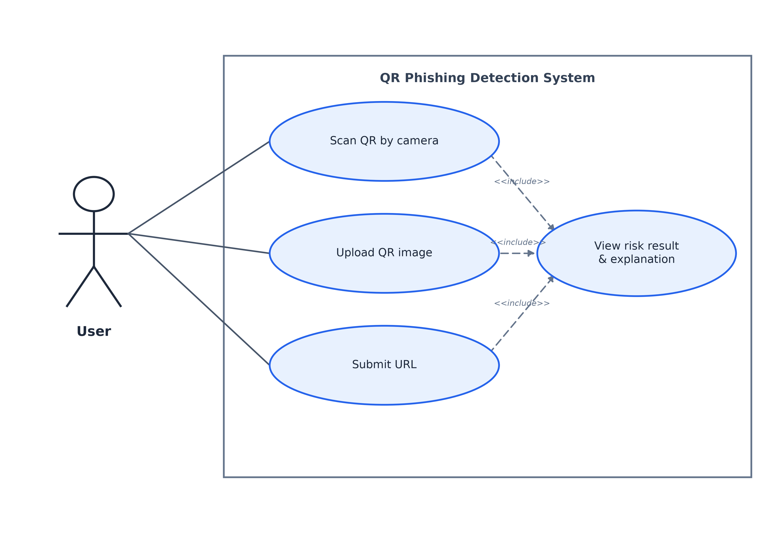
Figure 4.1: Use Case Diagram

4.4 Non-Functional Requirements

4.4.1 Performance
The system should classify a decoded URL and return a result with minimal delay, since the underlying model is lightweight (approximately 130,000 parameters) and intended for fast, interactive use.

4.4.2 Reliability
The framework should provide stable and consistent predictions for the same URL across repeated requests, and should correctly handle malformed or unusual URLs without failing.

4.4.3 Scalability
The system architecture should support future dataset expansion, additional brand coverage, and retraining with newer threat-feed data without requiring structural changes to the pipeline.

4.4.4 Usability
The framework should present its classification and explanation in a way that is understandable to a non-technical end user, consistent with the project’s emphasis on explainability over a pure black-box warning.

4.5 System Architecture Design
The proposed framework follows a modular pipeline architecture in which each stage performs one clearly defined task and passes its output to the next stage. Concretely, the pipeline comprises five stages — (1) QR decoding, (2) URL normalization, (3) dual-representation feature extraction (the character sequence and the brand-similarity features), (4) model inference, and (5) risk-level mapping and explanation generation. Each stage exposes a single, well-defined interface, so the components are independently testable and replaceable — for example, the model can be retrained or swapped without altering the decoding or presentation stages.
Each stage corresponds to a distinct software component. The QR Decoder converts an input image into its embedded text using pyzbar with an OpenCV fallback. The URL Normalizer standardizes the decoded text by lowercasing it and removing the scheme and any leading "www." prefix. The Feature Extractor produces the two model inputs: a fixed-length character sequence and the four brand-similarity features. The Classifier is the trained dual-input model, which outputs a probability distribution over the four classes. Finally, the Result Presenter maps the predicted class to a Safe, Risky, or Dangerous level and assembles the confidence score and human-readable indicators for display. The complete architecture and the connections between these components are shown in Figure 4.2.
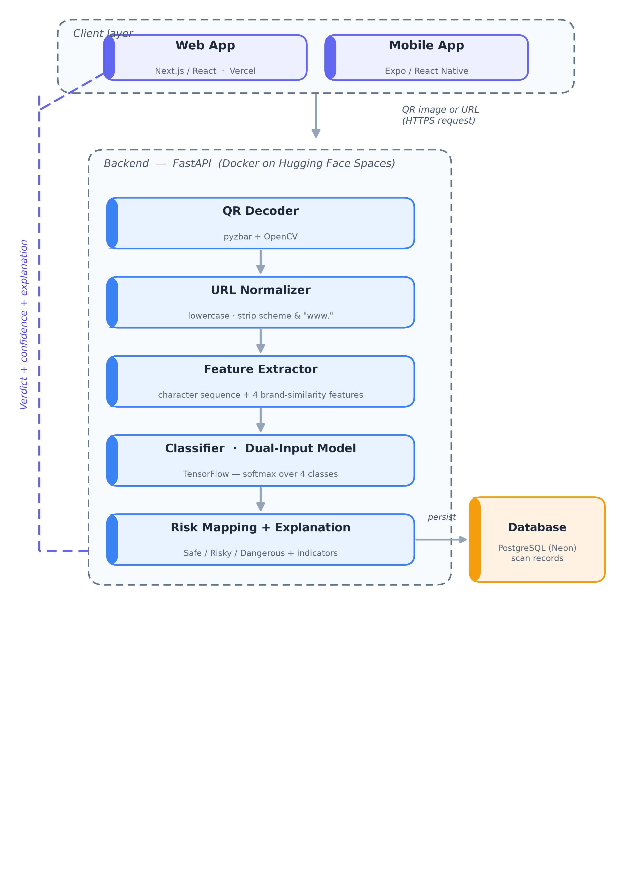
Figure 4.2: System Architecture Design

This architecture deliberately keeps the QR-decoding step separate from the classification step, reflecting the methodological decision in Chapter 3 that all security-relevant analysis happens on the decoded URL text, not on the QR image itself.

4.6 Workflow Design
The workflow ties the architecture components together into a single path from user input to a risk verdict. Because the decoding and analysis stages are decoupled, the same workflow serves both the image path (camera or uploaded file) and the direct URL-input path, with only the initial decoding stage differing between them.
The interaction proceeds as an ordered sequence: (1) the user submits a QR image or a URL; (2) the decoder extracts the embedded URL text, a step skipped when a URL is submitted directly; (3) the payload type is detected, and only http or https URLs proceed to analysis; (4) the URL is normalized and converted into the character sequence and the brand-similarity features; (5) the dual-input model produces a probability distribution over the four classes; (6) the highest-probability class is mapped to a risk level and threat type; and (7) the result, confidence score, and explanation are returned to the user. Figure 4.3 shows this interaction as a sequence diagram.
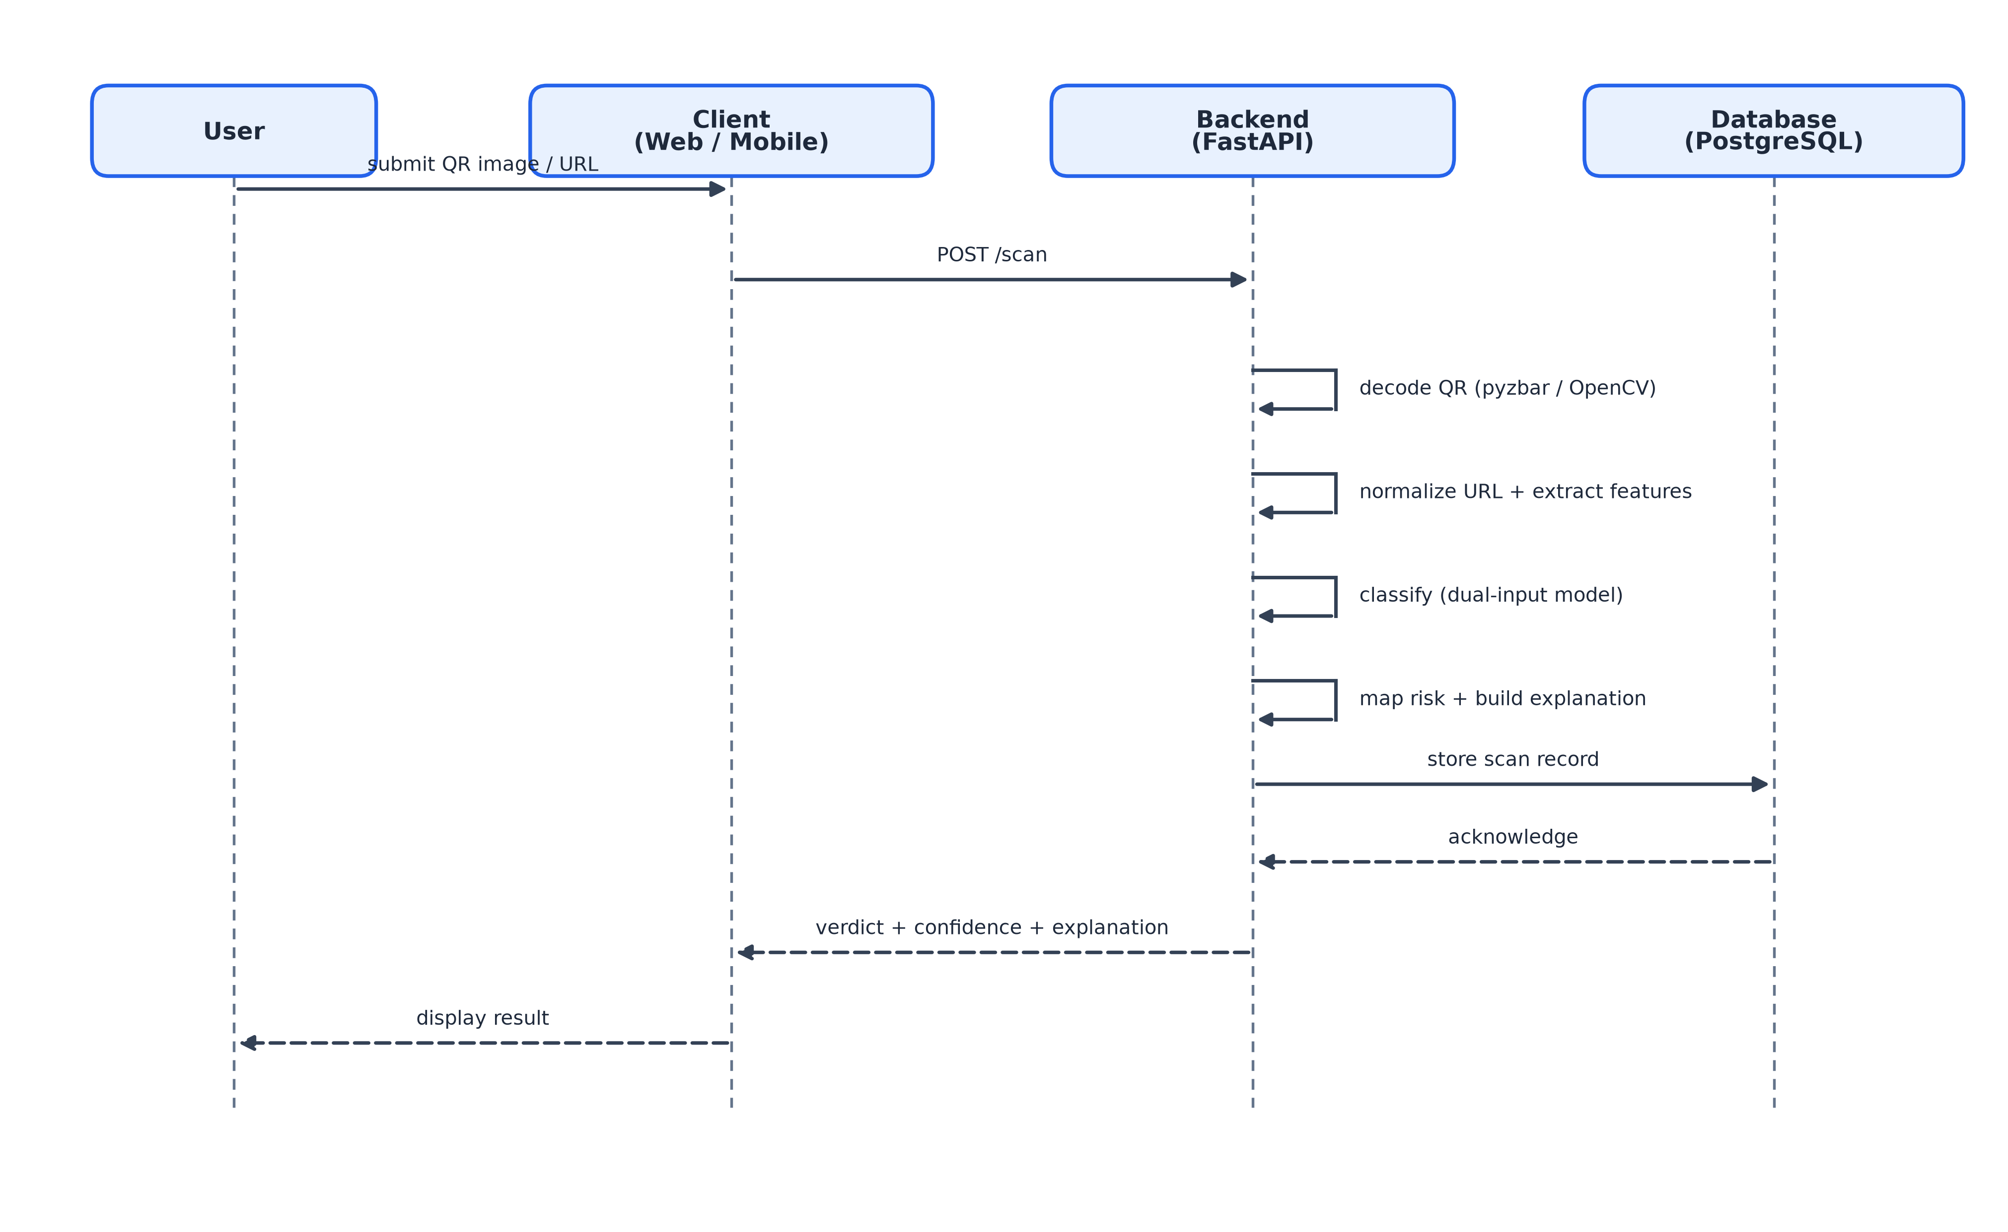
Figure 4.3: Sequence Diagram

4.7 Data Flow Diagram
The data flow begins with the QR code image supplied by the user. The image is decoded to extract the embedded URL text; no further use is made of the QR image itself beyond this decoding step. The URL text is normalized and transformed into the two model inputs described in Chapter 3. These are passed through the trained model to produce class probabilities, which are converted into a risk-level label and an accompanying explanation before being returned to the user. No part of the QR image is retained or transmitted after decoding; only the extracted URL text and its derived numerical representations flow through the remaining stages, keeping the data footprint minimal and the analysis fully text-based. Figure 4.4 presents the corresponding data-flow diagram (DFD), drawn with standard notation for the external entity (the user), the numbered processes, the data stores (the trained model, the brand reference list, and the scan records), and the labelled data flows between them.
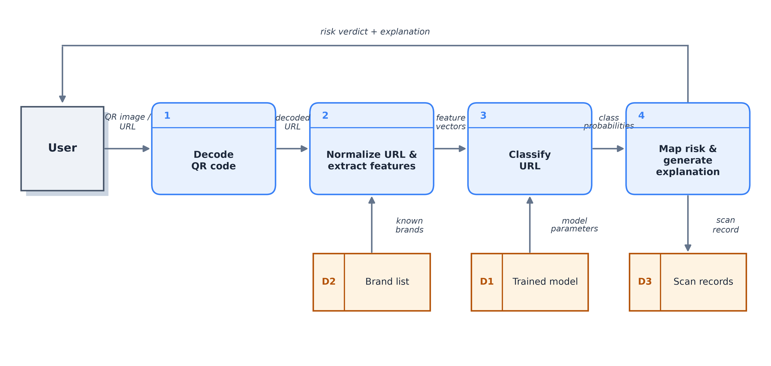
Figure 4.4: Data Flow Diagram

4.8 Database Design
The system persists the outcome of each scan in a single relational table, scan_records, hosted in a PostgreSQL database (Neon) and accessed through SQLAlchemy. The table records the decoded URL, the model’s verdict, and the supporting metadata, so that past scans can be logged and reviewed without re-running the model. Table 4.1 describes its schema.
Field | Type | Description
id | INTEGER (PK) | Auto-incrementing primary key
payload_kind | VARCHAR(32) | Decoded payload type (e.g., url, wifi); defaults to "url"
extracted_url | TEXT | URL decoded from the QR code
classification | VARCHAR(32) | Risk classification assigned (Safe / Risky / Dangerous)
confidence | FLOAT | Model confidence score for the verdict
indicators | JSON | Human-readable signals supporting the verdict
created_at | TIMESTAMP | Time the scan was recorded (defaults to current time)
Table 4.1: scan_records database schema

4.9 Development Environment
The system was developed across four layers, each with an appropriate toolchain. The dual-input model was trained in Google Colab using Python and TensorFlow/Keras, supported by Pandas, NumPy, and Scikit-learn for data preparation and evaluation, RapidFuzz for the brand-similarity edit-distance computation, and Matplotlib/Seaborn for result visualization. The backend was built with FastAPI (served by Uvicorn) and performs server-side QR-code decoding with pyzbar and OpenCV, image handling with Pillow and NumPy, and classification with the trained TensorFlow model; scan records are stored in a PostgreSQL database (Neon) through SQLAlchemy. The web client was built with Next.js and React, and the mobile client with Expo and React Native (NativeWind for styling and expo-camera for scanning). For deployment, the backend runs as a Docker container on Hugging Face Spaces and the web client on Vercel, with all source code managed under Git and GitHub. Table 4.2 summarizes the development environment.

Technology | Purpose
Python 3.11 | Core programming language for the model and the backend
TensorFlow / Keras | Dual-input model definition, training, and inference
Pandas / NumPy | Dataset construction and numerical processing
Scikit-learn | Train/validation/test split, class weighting, and metrics
RapidFuzz | Brand-similarity edit-distance computation during training
Matplotlib / Seaborn | Visualization of training and evaluation results
Google Colab (GPU) | Model training and experimentation platform
FastAPI / Uvicorn | Backend REST API that serves the trained model
pyzbar / OpenCV / Pillow | Server-side QR-code decoding and image handling
SQLAlchemy / PostgreSQL (Neon) | Persisting scan records in a cloud database
Next.js / React | Web client user interface
Expo / React Native / NativeWind | Cross-platform mobile client with camera scanning
Docker / Hugging Face Spaces | Containerized backend deployment
Vercel | Web client deployment
Git / GitHub | Version control and source management
Table 4.2: Development environment technologies

Chapter 5: Project Description

5.1 Introduction
This chapter describes the implementation process and experimental evaluation of the proposed dual-input Transformer-based URL classification framework. The implementation was carried out using TensorFlow/Keras in Google Colab.
The chapter covers the dataset, preprocessing and feature-engineering, model, and training implementation; the experimental results, including accuracy, the confusion matrix, safe-versus-threat security metrics, prediction confidence, the generalization test, and an ablation study; the implementation and demonstration of the complete web and mobile system; and a discussion of the findings.

5.2 Dataset Implementation
The dataset was implemented by combining the four sources described in Section 3.2.2 — the labelled benchmark CSV, live OpenPhish and URLhaus threat feeds, the Cisco Umbrella top global domains list, and a worldwide list of university domains — into a single combined dataset of 402,684 URLs. Python functions built on Pandas automated the fetching, deduplication, and labelling of each source, and the brand-attack augmentation described in Section 3.2.3 was applied to generate additional typosquatting, combosquatting, subdomain-abuse, and benign hard-negative examples. The combined dataset was cached as a CSV file on Google Drive so that subsequent runs could reload it directly rather than rebuilding it from scratch, and an automated verification step confirmed the presence and counts of the synthetic attack and benign-coverage rows after each build.

5.3 Preprocessing and Feature Engineering Implementation
Each URL was normalized (lowercased, with the scheme and any leading “www.” removed) and encoded as a fixed-length sequence of 200 character indices, padded with zeros where necessary, using a character vocabulary built exclusively from the training split to avoid data leakage into validation or test data. In parallel, the four brand-similarity features described in Section 3.2.3 were computed for every URL against a reference list of sixty-five seed brand domains, using Levenshtein edit distance (via the RapidFuzz library) and a reverse-homoglyph mapping. The same normalization and feature-extraction logic was used consistently across training, validation, and test data to ensure that the figures reported in this chapter reflect the model’s true behaviour.

5.4 Model Implementation
The dual-input model described in Section 3.2.4 was implemented using the Keras Functional API, since the architecture requires two separate inputs (the character sequence and the brand-similarity feature vector) to be merged partway through the network — something the simpler Sequential API cannot express. The character tower consisted of an embedding layer, a Conv1D layer, a multi-head self-attention block with residual connections and layer normalization, a feed-forward sub-block with a second residual connection, and global max pooling. The brand-similarity tower consisted of a single dense layer. The two towers were concatenated and passed through a final dense-and-softmax classification head producing probabilities for the four output classes. The complete model contained approximately 130,196 trainable parameters.

5.5 Model Training
The model was trained for up to 15 epochs with a batch size of 128, using the Adam optimizer, sparse categorical cross-entropy loss, and the class weights described in Section 3.2.3. Because the model is small — approximately 130,000 parameters — each epoch was computationally inexpensive, so the full training run completed quickly on the Colab GPU.
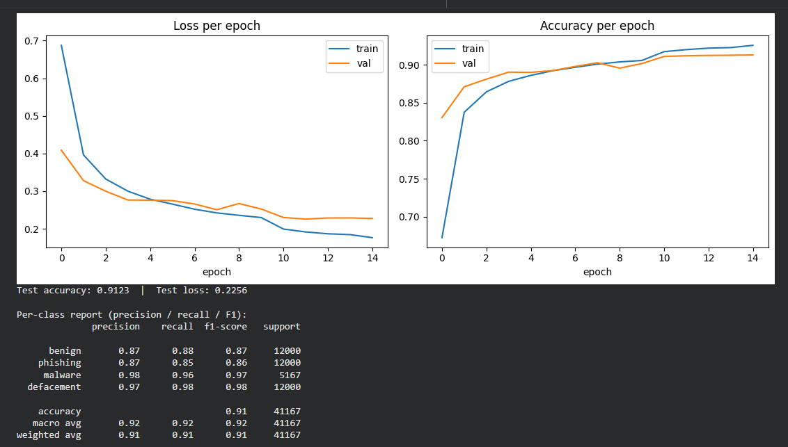
Figure 5.1: Training/validation accuracy & loss curves

Early stopping (patience of three epochs, monitoring validation loss) and learning-rate reduction on plateau were applied throughout training. Table 5.1 summarizes the training progression.
Epoch | Training accuracy | Validation accuracy | Validation loss
1 | 67.2% | 83.1% | 0.409
5 | 88.6% | 89.0% | 0.276
10 | 90.6% | 90.2% | 0.252
15 (final) | 92.6% | 91.3% | 0.227
Table 5.1: Training progression (selected epochs)
Training and validation accuracy rose together throughout training, and validation loss decreased steadily without diverging from training loss, indicating that the model learned generalizable patterns rather than overfitting to the training data.

5.6 Experimental Results
On the held-out test set of 41,167 URLs, the trained model achieved an overall test accuracy of 91.23%, with a test loss of 0.226. Table 5.2 presents the detailed classification report.
Class | Precision | Recall | F1-score | Support
Benign | 0.87 | 0.88 | 0.87 | 12,000
Phishing | 0.87 | 0.85 | 0.86 | 12,000
Malware | 0.98 | 0.96 | 0.97 | 5,167
Defacement | 0.97 | 0.98 | 0.98 | 12,000
Macro average | 0.92 | 0.92 | 0.92 | 41,167
Weighted average | 0.91 | 0.91 | 0.91 | 41,167
Table 5.2: Per-class classification report on the test set

The malware and defacement classes were classified with the highest precision and recall, likely because these categories tend to contain more structurally distinctive URLs (long random paths, suspicious file extensions, unusual hosting patterns). The benign and phishing classes showed comparatively more confusion with each other, which is expected given that the hard-negative augmentation in Section 3.2.3 deliberately placed sensitive-looking paths (such as “/login”) on genuine benign domains specifically to make this distinction harder and more realistic.
Collapsing the four-class output into a binary “safe vs. threat” view (benign vs. any of phishing, malware, or defacement) — the metric that most directly reflects the system’s real-world security decision — produced an overall accuracy of 93%, with the threat class reaching a precision and recall of 0.95 each, and an ROC-AUC of approximately 0.97 for the safe-versus-threat decision.
These results are competitive with prior URL-based phishing detectors reviewed in Chapter 2. Character-level CNN approaches (Aljofey et al., 2020) and CNN–ensemble methods (Yang et al., 2021) report accuracies in the 95–99% range, while the closest QR-specific image-based study (Trad and Chehab, 2025) reports an AUC of 0.91 for binary classification. A direct numerical comparison is not strictly valid, as these works use different datasets, class definitions and (in most cases) only binary labels; the present study instead targets a harder four-class, QR-decoded setting with an explicit brand-impersonation focus and a held-out generalization test, while still achieving a 0.97 safe-versus-threat ROC-AUC.
Beyond classification quality, the model’s inference speed was measured to confirm its suitability for interactive use. On a standard CPU, without any GPU acceleration, a single URL — including normalization, brand-similarity feature computation, and model inference — was classified in approximately 62 milliseconds on average, corresponding to a throughput of about 16 URLs per second on a single thread. This sub-100-millisecond latency satisfies the performance requirement stated in Section 4.4.1: the lightweight 130,196-parameter model returns a verdict fast enough for a responsive, interactive scan even on modest, CPU-only hardware such as the free Hugging Face Spaces tier used for deployment.
Table 5.3 consolidates the key quantitative results obtained for the proposed model.
Metric | Value
Overall test accuracy (4-class) | 91.23%
Test loss | 0.226
Safe-vs-threat accuracy | 93%
Threat-class precision / recall | 0.95 / 0.95
Safe-vs-threat ROC-AUC | 0.97
Inference latency (CPU) | ~62 ms per URL (~16 URLs/sec)
Table 5.3: Summary of key results

5.7 Confusion Matrix Analysis
The 4×4 confusion matrix on the test set showed that the great majority of predictions fell on the diagonal, confirming that the model correctly separates the four classes in most cases. Figure 5.2 presents the full confusion matrix as a heatmap.
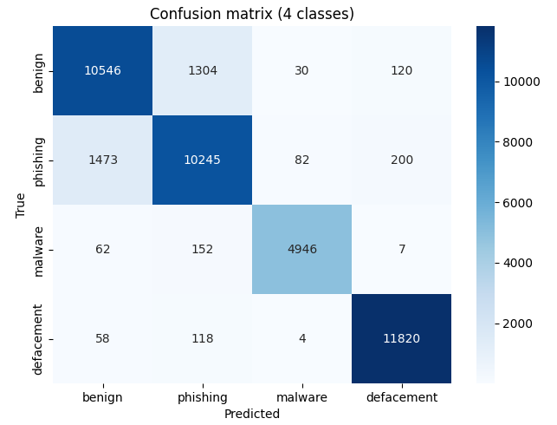
Figure 5.2: 4×4 confusion matrix heatmap

The most frequent confusion occurred between the benign and phishing classes, consistent with the precision/recall figures in Table 5.2: a number of benign URLs containing brand names and sensitive-looking paths were occasionally misclassified as phishing, and vice versa. Confusion between malware/defacement and the other two classes was comparatively rare, reflected in their higher F1-scores. The per-class F1 scores are shown in Figure 5.3.
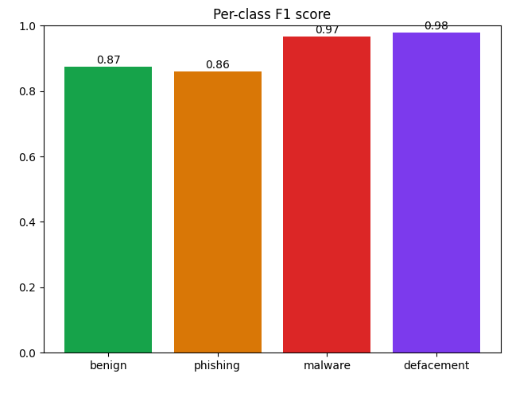
Figure 5.3: Per-class F1 bar chart

5.8 Safe-vs-Threat Security Metrics
In addition to the per-class report in Table 5.2, the safe-versus-threat security view was examined directly, since in practice the system’s most important job is to decide whether a scanned QR code’s URL is safe to open at all. The corresponding ROC curve is shown in Figure 5.4.
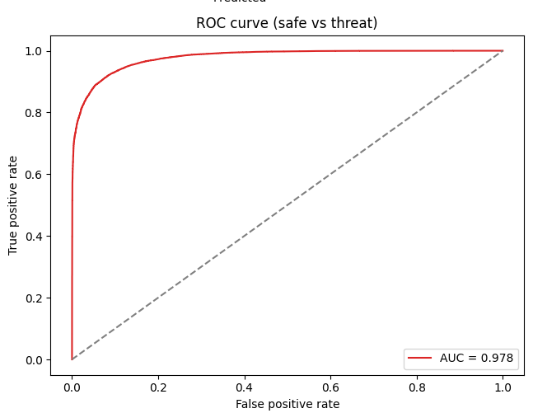
Figure 5.4: ROC curve (safe vs threat)
On the test set, the number of missed threats (malicious URLs incorrectly classified as benign) and false alarms (benign URLs incorrectly flagged as a threat) were both measured directly; both rates were consistent with the 87% precision and 88% recall obtained for the benign class, and the 95% precision and recall obtained for the combined threat classes.

5.9 Prediction Confidence Analysis
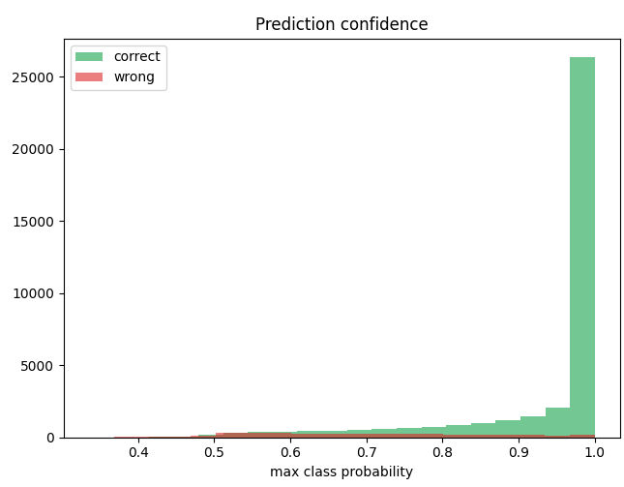
Figure 5.5: Confidence histogram (correct vs wrong)
A confidence histogram (Figure 5.5) shows the distribution of the model’s maximum class probability for correct versus incorrect predictions. Correct predictions were heavily concentrated at high confidence values, while incorrect predictions were spread more broadly across the confidence range. This indicates that the model’s confidence score is a reasonably useful signal of its own reliability: high-confidence verdicts can be trusted more, while low-confidence outputs can be flagged for additional caution.

5.10 Generalization Test on Real-World and Held-Out Brands
To verify that the model generalizes beyond its training data, it was tested on three additional sets of URLs that were never part of training or evaluation:
- A set of genuinely safe URLs, including deliberately tricky cases such as brand domains with sensitive-looking paths (for example, “github.com/login”, “accounts.google.com/signin”) and locally relevant Bangladeshi brand domains (for example, “bkash.com”).
- A set of clearly malicious URLs, including IP-address hosts, the “@” obfuscation trick, and shortened links.
- A set of look-alike attacks built from “dropbox.com”, “reddit.com”, and “pickaboo.com” — three brands that were deliberately excluded from the brand-attack augmentation process in Section 3.2.3, so that correct detection here demonstrates that the model has learned the general pattern of brand impersonation rather than memorizing specific brand names.
The model correctly handled the great majority of these unseen cases, correctly flagging the held-out brand look-alikes as non-benign despite never having seen augmented attacks built from those specific brand names during training. Representative results for the legitimate, phishing, and held-out brand cases are shown in Figure 5.6.
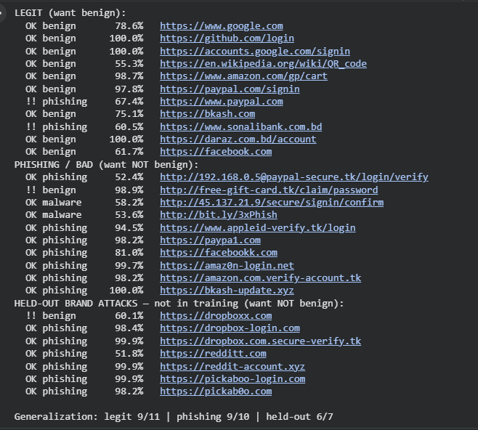
Figure 5.6: Screenshot of legit/phish/held-out test results
A small number of edge cases were misclassified — most notably, the bare root domains “paypal.com” and “sonalibank.com.bd” were occasionally flagged as phishing with moderate confidence, illustrating a residual limitation: brand names that frequently appear as the target of phishing impersonation can themselves carry a textual “phishing-adjacent” signal that the model has not yet fully learned to override for the genuine root domain. This is discussed further as a limitation in Chapter 6. In the deployed system an exact brand-match safeguard resolves this for genuine brand domains, so it remains a limitation at the pure-model level rather than in the end-to-end system.

5.11 Ablation Study: Contribution of the Brand-Similarity Features
To isolate the contribution of the four brand-similarity features, an ablation study was conducted. A character-only variant of the model — retaining the identical character Transformer tower but with the brand-similarity tower removed — was trained on the same data, with the same training schedule, and evaluated on the same held-out test set. Comparing this variant against the full dual-input model directly measures what the engineered features contribute. Table 5.4 reports the comparison.
Metric | Char-only | Dual-input
Overall accuracy | 0.9147 | 0.9120
Macro F1 | 0.9222 | 0.9192
Safe-vs-threat ROC-AUC | 0.9792 | 0.9779
Accuracy on brand-impersonation subset (n = 142) | 0.8662 | 0.8310
Table 5.4: Ablation — character-only versus dual-input model
Contrary to the initial expectation, the two variants performed almost identically. The differences in overall accuracy, macro-averaged F1, and safe-versus-threat ROC-AUC are all below 0.3 of a percentage point — well within the run-to-run variance of neural-network training — and on the brand-impersonation subset (the URLs whose near-miss or homoglyph feature fired, n = 142) the character-only variant was in fact marginally higher. The explicit brand-similarity features therefore did not produce a measurable improvement in classification accuracy on the held-out test set.
The most plausible explanation is that the attack augmentation described in Section 3.2.3 already exposes the character tower to a large number of typosquatting, combosquatting, and homoglyph examples during training. Once that augmentation is present, the character-level encoder learns the impersonation pattern directly from the URL text, so the explicit edit-distance and homoglyph features add little additional discriminative information. The augmentation — rather than the engineered feature tower — is thus the primary driver of the model’s robustness to brand impersonation.
This is a useful negative result, and it does not make the brand-similarity features redundant. Beyond classification, they provide explicit, human-readable signals — the exact edit distance to the nearest known brand, together with the near-miss and homoglyph flags — that are surfaced directly in the system’s explanation layer (Section 4.3.5) and underpin the exact brand-match safeguard used in deployment (Section 5.10). A character-only model attains comparable accuracy but keeps these signals implicit in its learned weights, where they cannot be shown to the user. The brand-similarity features therefore contribute primarily to the system’s explainability rather than to a measurable accuracy gain.

5.12 System Implementation
While the preceding sections describe the model and its evaluation, this section describes how the trained model was integrated into a complete, working system. The system follows a client–server design that realises the architecture of Section 4.5: a backend service hosts the model, and two thin clients — a web application and a mobile application — provide the user interface.
The backend was implemented with FastAPI. On startup, the trained model (phishing_url_model.keras) and its tokenizer (url_tokenizer.json) are loaded into memory once, so that every request reuses the same in-memory model rather than reloading it. The service exposes two main endpoints under the /api/v1 prefix: /scan, which accepts an uploaded image, and /scan-url, which accepts a URL or text directly; a health endpoint is also provided for monitoring. For an uploaded image, the embedded payload is decoded server-side using pyzbar with an OpenCV fallback. The decoded payload type is then detected, and only http and https URLs are passed to the model, while other payloads such as Wi-Fi credentials or plain text are reported without classification. For a URL payload, the same normalization and brand-similarity feature computation used during training is applied, the dual-input model is run, and the predicted class and confidence are mapped to a Safe, Risky, or Dangerous verdict together with a list of human-readable indicators. Each result is returned as a JSON response and persisted to the scan_records table described in Section 4.8.
Two clients consume this API. The web application was built with Next.js and React, and the mobile application with Expo and React Native. Both offer three input modes — capturing a QR code with the device camera, uploading an existing QR image, and pasting a URL directly — and render the returned verdict, confidence score, and contributing indicators; the mobile client uses expo-camera for live scanning. Because both clients call the same backend, they produce identical verdicts for the same input. For deployment, the backend is packaged as a Docker container and hosted on Hugging Face Spaces, while the web client is deployed on Vercel, so the model is served from a single shared endpoint that both clients reach over HTTPS.

5.13 Application Interface and End-to-End Demonstration
Having described the system implementation in Section 5.12, this section demonstrates the complete end-to-end flow as experienced by an end user, using screenshots captured from both the web and mobile clients. In every case the user submits a QR code or a URL and receives a verdict — Safe, Risky, or Dangerous — together with a confidence score and the contributing indicators, before any destination link is opened.
Figure 5.7 shows the web application classifying a legitimate URL, where the result card reports a Safe verdict with the decoded destination and supporting indicators. Figure 5.8 shows the same interface classifying a phishing URL, where the verdict changes to a high-confidence Dangerous result with the threat type identified.
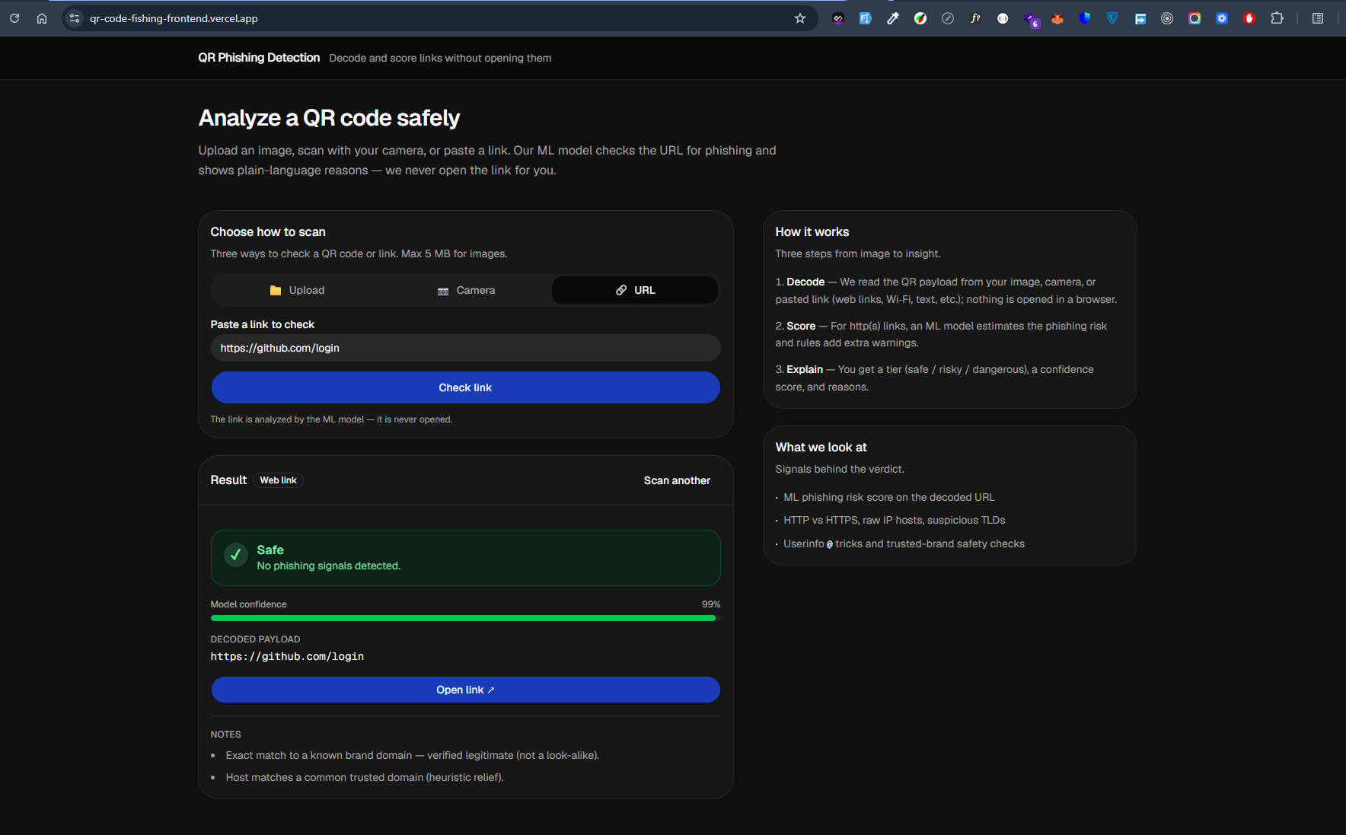
Figure 5.7: Web application — Safe (benign) result
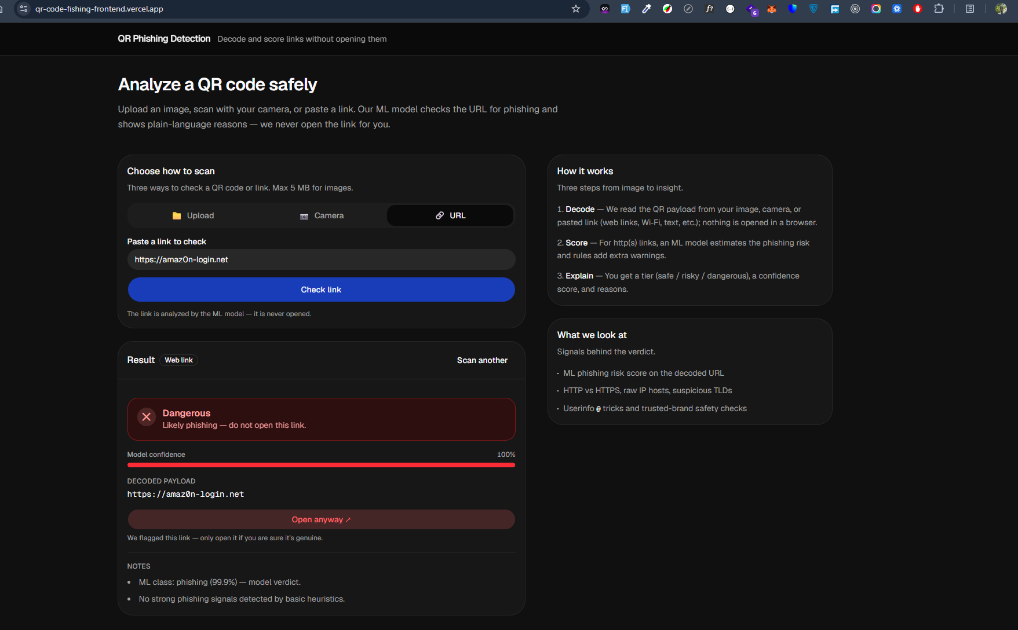
Figure 5.8: Web application — Phishing (Dangerous) result
The mobile application offers the same capability on a smartphone. Figure 5.9 shows a benign QR code captured with the device camera, producing a Safe verdict, while Figure 5.10 shows a phishing QR code producing a Dangerous verdict. Because both clients rely on the same backend service, the verdicts are consistent across platforms for the same input.
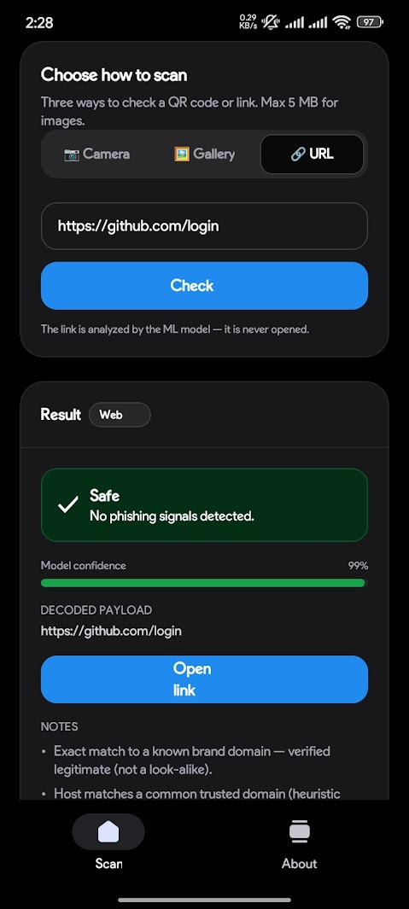
Figure 5.9: Mobile application — Safe (benign) result
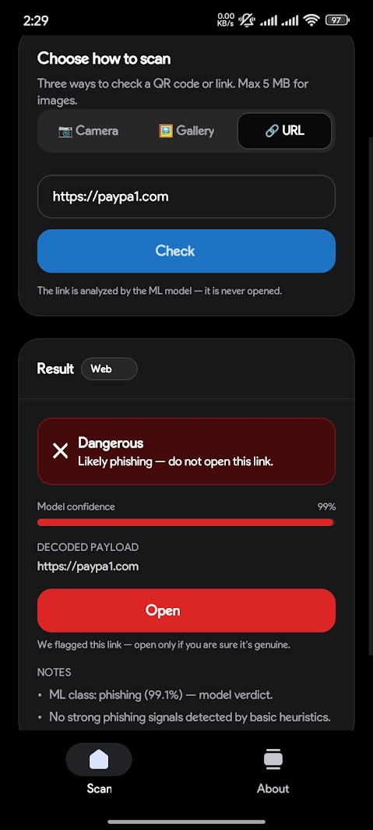
Figure 5.10: Mobile application — Phishing (Dangerous) result
Together, these screenshots demonstrate the full data flow of the system in practice — from QR input, through backend decoding and model inference, to a human-readable risk verdict — confirming that the model is usable as the core of a deployable phishing-detection tool.

5.14 Discussion
The experimental findings indicate that a hybrid, character-level Transformer model combined with explicit brand-similarity features can classify the URLs embedded in QR codes into four meaningful risk categories with strong overall accuracy (91.2% multi-class, 93% in the collapsed safe-versus-threat view). The brand-similarity features were designed to address typosquatting and brand impersonation, attack patterns that are central to QR-code phishing. The ablation study in Section 5.11, however, showed that a character-only variant trained on the same augmented data reached comparable accuracy, indicating that the brand-attack augmentation — rather than the explicit features — is the principal driver of the model’s robustness to impersonation; the features’ main contribution is to the system’s explainability. The held-out generalization test (Section 5.10) nonetheless confirms that the overall approach detects previously unseen impersonation patterns, although residual false positives on a small number of genuine root-brand domains show that this is not yet fully solved. The use of class weighting, dropout, early stopping, and learning-rate reduction collectively helped the model avoid overfitting, as shown by the closely tracking training and validation curves in Section 5.9. These findings also reinforce the core methodological position of this research: because a QR code’s danger lies entirely in its decoded URL rather than in its visual pattern, a text-based classification approach is both a more direct and a more data-efficient way to address QR-code phishing than attempting to learn malice from the QR image itself.

Chapter 6: Conclusion

6.1 Introduction
This chapter presents the conclusion of the proposed research work and summarizes the major findings of the study described in Chapters 3 through 5. It also discusses the limitations of the current implementation and outlines opportunities for future improvement.

6.2 Research Summary
This research proposed an explainable machine learning framework for detecting phishing and malicious URLs embedded in QR codes. Because a QR code is only a lossless visual encoding of text — a safe and a malicious QR code look identical as a pattern of modules — the framework’s core insight was to treat the problem as a URL-classification task rather than an image-classification task: the QR code is decoded to recover its embedded URL, and that URL text is what is analyzed for risk.
A complete machine learning workflow was implemented, covering multi-source dataset construction (a labelled benchmark dataset, live OpenPhish and URLhaus threat feeds, global domain lists, and university domains), brand-attack augmentation to address typosquatting and brand impersonation, character-level tokenization and brand-similarity feature engineering, the design and training of a dual-input Transformer-based neural network, and a thorough evaluation that included both a held-out test set and a dedicated generalization test on brands withheld from training.
The proposed model successfully classified URLs into four categories — benign, phishing, malware, and defacement — achieving an overall test accuracy of 91.2%, and 93% accuracy when the output is collapsed into the practical safe-versus-threat security decision. The model also demonstrated the ability to correctly flag look-alike attacks built from brand names it had never seen augmented during training, indicating that it learned a generalizable pattern of brand impersonation rather than memorizing specific examples.

6.3 Research Contribution
The proposed research contributed to QR code and URL-phishing cybersecurity research in several ways:
- It demonstrated that QR-code phishing (“quishing”) can be addressed effectively by classifying the decoded URL text, avoiding the unnecessary complexity and weaker signal of trying to learn malice directly from the QR code’s visual pattern.
- It introduced a dual-input architecture that fuses a Transformer-style character encoder with explicit, engineered brand-similarity features (edit distance, near-miss, and homoglyph detection), and — through an ablation study (Section 5.11) — established that, once brand-attack augmentation is applied, these features serve primarily to make the model’s decisions explainable rather than to increase its accuracy.
- It used a four-class formulation (benign, phishing, malware, defacement) rather than a simple binary split, giving a more fine-grained risk signal than most prior QR-focused work, which has typically been limited to binary classification.
- It validated the model’s generalization ability through a held-out brand test, an evaluation step that is often missing from comparable studies but is essential for demonstrating that a phishing detector has learned a transferable pattern rather than a memorized list of brands.

6.4 Limitations
Although the proposed framework achieved promising performance, several limitations remain.
- The model occasionally misclassified the bare root domains of well-known brands (for example, “paypal.com” and “sonalibank.com.bd”) as phishing with moderate confidence, as observed in the Section 5.10 generalization test. This suggests that brand names which are frequently impersonated can themselves leave a textual signal that the model has not yet fully learned to discount for the genuine domain. In the deployed end-to-end system this specific case is mitigated by an exact brand-match safeguard that treats a host which is exactly a known brand (or a subdomain of one) as legitimate; it therefore remains a limitation of the pure model rather than of the overall system.
- The benign and phishing classes showed more confusion with each other (Section 5.7) than the malware and defacement classes, reflecting the inherent difficulty of separating genuine brand-related URLs with sensitive-looking paths from true phishing pages that mimic the same pattern.
- The malware class remained smaller than the other three classes even after dataset balancing, and while class weighting was used to compensate during training, additional malware-specific data would likely improve robustness further.
- The system explains each verdict through a set of human-readable indicators — for example, the predicted class and its confidence, an exact brand-domain match, or a suspicious top-level-domain flag — rather than through a formal feature-attribution method. A more rigorous, feature-level explanation using techniques such as SHAP or LIME was not implemented or evaluated in this work and remains a direction for future research.
- The system was evaluated on the decoded URL text only; it does not yet incorporate live destination-page content (for example, fetching and analyzing the landing page itself), which could catch attacks that rely on a clean-looking URL leading to a malicious page.

6.5 Future Work
Several directions can extend and strengthen the proposed framework:
- Expanding the brand-similarity reference list and the volume of malware-class training data to further reduce false positives on genuine brand domains and improve coverage of less common attack types.
- Adding a feature-attribution explanation layer (for example, SHAP or LIME) on top of the trained URL classifier, so that end users receive a concrete, feature-level explanation of each prediction in addition to the current rule-based indicators.
- Hardening the prototype web and mobile clients demonstrated in Section 5.12 into a production-grade, real-time deployment — including on-device inference and the interception of links before a destination is opened — rather than the current server-side, upload-based prototype.
- Incorporating destination-page analysis (fetching and inspecting the landing page content) as a complementary signal alongside the URL-text classifier, to catch cases where the URL itself looks unremarkable but the destination page is malicious.
- Exploring larger or alternative architectures (for example, deeper Transformer encoders or pretrained character/byte-level language models) to assess whether they can improve on the 91.2% test accuracy achieved by the current model, particularly for the benign-versus-phishing boundary.
- Continuously retraining on live threat-feed data (as already supported by the OpenPhish/URLhaus integration in Section 3.2.2) to keep the model current as new phishing campaigns and domains emerge.

6.6 Final Conclusion
The rapid growth of QR code usage across payments, authentication, and advertising has increased the cybersecurity risks associated with phishing attacks and malicious redirects hidden behind a scan. This research demonstrated that, because a QR code’s danger lies entirely in the URL it encodes rather than in its visual pattern, an explainable, URL-text-based classification approach is a direct and effective way to address this threat. The proposed dual-input Transformer model, which combines a character encoder with engineered brand-similarity features that support its explainability, achieved a test accuracy of 91.2% across four classes and 93% in the practical safe-versus-threat view, and was shown to generalize to brand impersonation attacks it had never encountered during training.
Overall, the study successfully validated its research objective — that a hybrid character-level and brand-similarity-aware machine learning model can reliably distinguish safe URLs from phishing, malware, and defacement links extracted from QR codes — and established a practical, reproducible foundation for future research in QR-code phishing detection and explainable cybersecurity systems.
References
[1] Aldakheel, E.A., Zakariah, M., Gashgari, G.A., Almarshad, F.A. and Alzahrani, A.I.A. (2023). A Deep Learning-Based Innovative Technique for Phishing Detection in Modern Security with Uniform Resource Locators. Sensors, 23(9), p.4403. doi:https://doi.org/10.3390/s23094403.
[2] Aljofey, A., Jiang, Q., Qu, Q., Huang, M. and Niyigena, J.-P. (2020). An Effective Phishing Detection Model Based on Character Level Convolutional Neural Network from URL. Electronics, 9(9), p.1514. doi:https://doi.org/10.3390/electronics9091514.
[3] Hamadouche, S., Boudraa, O. and Gasmi, M. (2024). Combining Lexical, Host, and Content-based features for Phishing Websites detection using Machine Learning Models. ICST Transactions on Scalable Information Systems. doi:https://doi.org/10.4108/eetsis.4421.
[4] Jaswanthi, T., Harshitha, T., Tanya, S. and Belwal, M. (2024). Malicious URL Detection: Comparative Study of Machine Learning Algorithms. 2024 15th International Conference on Computing Communication and Networking Technologies (ICCCNT), pp.1–5. doi:https://doi.org/10.1109/icccnt61001.2024.10725561.
[5] Krombholz, K., Frühwirt, P., Kieseberg, P., Kapsalis, I., Huber, M. and Weippl, E. (2021). QR Code Security: A Survey of Attacks and Challenges for Usable Security. [online] Available at: https://publications.sba-research.org/publications/llncs.pdf.
[6] Lim, B., Huerta, R., Sotelo, A., Quintela, A. and Kumar, P. (2025). EXPLICATE: Enhancing Phishing Detection through Explainable AI and LLM-Powered Interpretability. [online] arXiv.org. Available at: https://arxiv.org/abs/2503.20796.
[7] Mohi, M., Biswas, N., Sarreha Tasmin Rikta, Md. Nur-A-Alam and Rafid Mostafiz (2025). Explainable Machine Learning for Phishing Site Detection: A High-Efficiency Approach Using Boosting Models and SHAP. The Journal of Engineering, 2025(1). doi:https://doi.org/10.1049/tje2.70110.
[8] Qazi, E. ul H., Faheem, M.H. and Ahmad, I. (2024). Detecting Phishing URLs Based on a Deep Learning Approach to Prevent Cyber-Attacks. Applied Sciences, 14(22), pp.10086–10086. doi:https://doi.org/10.3390/app142210086.
[9] Sahoo, D., Liu, C. and Hoi, S.C.H. (2017). Malicious URL Detection using Machine Learning: A Survey. [online] arXiv.org. Available at: https://arxiv.org/abs/1701.07179.
[10] Shafin, S.S. (2024). An Explainable Feature Selection Framework for Web Phishing Detection with Machine Learning. Data Science and Management. doi:https://doi.org/10.1016/j.dsm.2024.08.004.
[11] Trad, F. and Chehab, A. (2025). Detecting Quishing Attacks with Machine Learning Techniques Through QR Code Analysis. [online] arXiv.org. Available at: https://arxiv.org/abs/2505.03451.
[12] Vidas, T., Owusu, E., Wang, S., Zeng, C., Cranor, L.F. and Christin, N. (2013). QRishing: The Susceptibility of Smartphone Users to QR Code Phishing Attacks. Financial Cryptography and Data Security, pp.52–69. doi:https://doi.org/10.1007/978-3-642-41320-9_4.
[13] Yang, R., Zheng, K., Wu, B., Wu, C. and Wang, X. (2021). Phishing Website Detection Based on Deep Convolutional Neural Network and Random Forest Ensemble Learning. Sensors, 21(24), p.8281. doi:https://doi.org/10.3390/s21248281.
[14] Vaswani, A., Shazeer, N., Parmar, N., Uszkoreit, J., Jones, L., Gomez, A.N., Kaiser, Ł. and Polosukhin, I. (2017). Attention Is All You Need. Advances in Neural Information Processing Systems (NeurIPS), 30.
[15] Kingma, D.P. and Ba, J. (2015). Adam: A Method for Stochastic Optimization. International Conference on Learning Representations (ICLR).

